How to Create a Windows XP Password Reset Disk
Article Source:
http://recoverlostpassword.com/article/create-windows-xp-password-reset-disk.html
If you are running Microsoft Windows XP professional, it is obligatory for you to create a Windows XP password reset disk. Whit it, you’ll never concern about forgetting Windows XP password because you can easily reset Windows XP password with Windows XP password reset disk within seconds.
Here is how to create a windows password XP reset disk
Requirements：Before you create a Windows XP password reset disk, what you need is a blank, formatted floppy disk and a floppy disk drive.
Step 1: Log on to your computer as an administrator account.
Step 2: Click on Start and then Control Panel in your Windows XP.
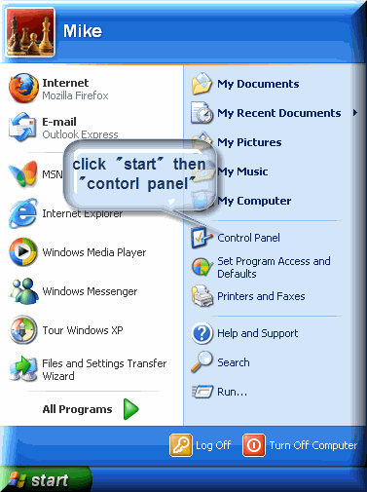
Step 3: Click on the User Accounts link.

Step 4: In the User Accounts pane, click the account that you want to create a password reset disk for, and then click Prevent a forgotten password.
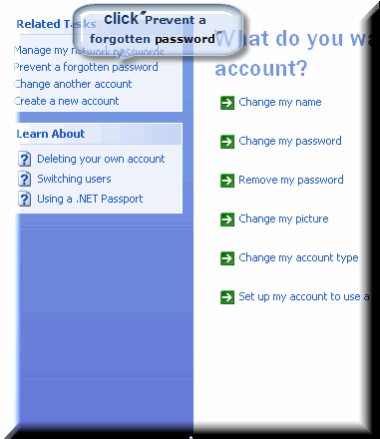
Step 5: With the Forgotten Password Wizard window appears, click Next.
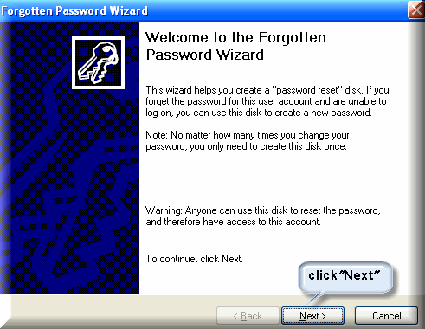
Step 6: Insert a floppy disk or a blank USB flash drive into your disk drive. In the Current user account password box, type the password for the user account and then click Next.
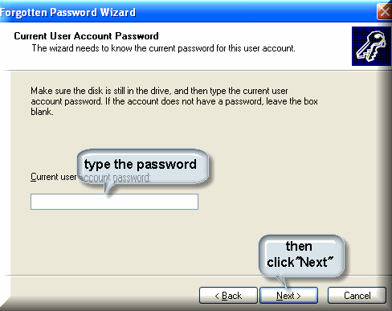
Step 7: Windows XP will now create the password reset disk. When the Progress bar reaches 100% complete, click Next, and then click Finish in the next window.
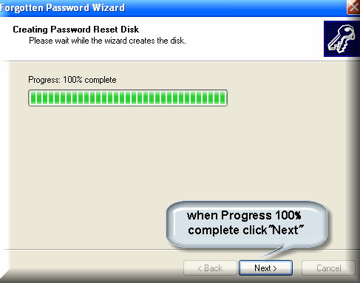
Now you have successfully created a Windows XP password reset disk, you can remove your password reset disk from your computer. There is one thing you have to note is anyone who uses the disk can reset your windows password without knowing your password. So store your password reset disk in a safe place.
If you forget Windows XP password and don’t have a password reset disk, while many people probably have totally told you that the only way to login on to your computer is to fully re-install Windows XP. They are totally wrong. You can still perform Windows XP password reset with Windows Password Recovery tool and log to your computer with ease. Windows Password Recovery Software can help you reset windows XP password by burning a bootable CD/DVD or USB flash drive. Except windows XP password resetting, Windows Password Recovery Tool can also help to reset windows administrator password and standard user password on Windows 7/Vista/Sever 2008/2003 etc.

